Appendix 'A'

Preparation for the 2016 Actuarial Valuation

Introduction

At its last meeting the Board received a report, which was also considered by the Pension Fund Committee, setting out a proposed initial position on various issues associated with the 2016 actuarial valuation of the Fund. This report provides the Board with further information on the proposed process and timeline.

Initial Framework

The key elements of the initial framework which employers have been asked to respond on by 15 January 2016 are:

- Overall valuation approach – a proposal to move away from the "gilts +" valuation basis to a "CPI +" basis which will provide a more stable view of liabilities. This is also more in line with the approach the Government Actuary will use to assess the cost of the scheme against the cost cap.
- Deficit Recovery Period – bringing the period down to 16 years in line with elapsed time.
- An aim to maintain the 2013 contributions plan in terms of total cash to be received as contributions.

Elements of these proposals were discussed at the annual "Director's Brief" and a discussion has been arranged with academy schools on 8 January 2016. At the time of writing no specific responses either positive or negative to the proposed framework have been received.

Further Preparatory Work

Alongside this consultation on the initial framework, the results of which are scheduled to be considered by the Pension Fund Committee, on 1 April 2016 a number of other pieces of preparatory work are being undertaken.

- Data Management – Work is being undertaken as part of business as usual to address employer data issues. In general this is a collaborative process between the Fund and employers. However, specific action is to be taken in the case of a small number of employers (covering a very small proportion of members) who have consistently failed to provide accurate data on time. This will include reporting those employers to the Regulator. Given timescales for the submission of final data it is important to resolve any data issues prior to the valuation date.
- Covenant Assessment – Work has been undertaken to assess the financial covenant of employers. This work has identified a small number of relatively small employers who's participation within the Fund represents a high risk for the Fund. The Pension Fund Committee will be asked to agree a course of action in these cases at its April meeting when it receives the results of this work.
- Additional Actuarial Modelling – The change in the valuation approach will impact different employers in different ways as it will tend to switch the emphasis from deficit contributions to future service contributions Depending on the nature of an employer's membership in the scheme this will have different impacts and work is being undertaken to model these impacts for a representative sample of employers (e.g. one with a relatively young workforce, one with a preponderance of pensioners, one who's participation in the scheme is relatively recent). This modelling will allow officers to anticipate areas where there might be issues when the final valuation results come through and engage in early discussions with employers. Larger employers such as the County Council and the two unitary councils which tend to be representative of the fund as a whole are less likely to be affected by this change.
- Actuarial Assumptions – There will be further engagement with the actuary around key assumptions within the model over the period to March. These will include future pay increases, where some research on historical trends will be fed into the process; the relationship between RPI and CPI and the reliability of market implied inflation measures; and the assumed level of returns from individual asset classes when compared to actual local assets. This process will not necessarily change any assumptions, but it will enable the Fund's officers to make them more transparent and explicable to employers.

Timetable

The broad timetable is set out below

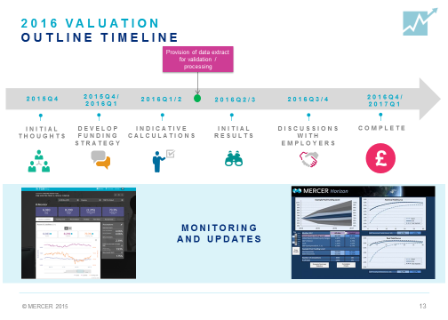
Running alongside this local process the actuary is required by July to provide the Government Actuary with a valuation carried out using a standardised methodology which will be used in the cost cap calculation for the scheme nationally. Given the assumptions that are used in this valuation there are likely to be some differences from the local result which will use more tailored assumptions.

Individual teams such as the Your Pension Service Data Centre have specific detailed project plans to deliver accurate data to the actuary in line with the required timescales.

The intention locally is that as in previous years the Fund will run sessions for specific employer groups (such as councils and universities and colleges) as early as possible in the process in order to provide clear indication and assistance in financial planning. In addition, at the end of the process prior to the final report being considered by the Pension Fund Committee every employer will be offered the opportunity for dialogue with the actuary and an officer from the fund to discuss their own specific circumstances and their proposed contribution rates. This dialogue also acts as a consultation process that feeds in to the preparation of the Funding Strategy Statement which will be considered by the Pension Fund Committee alongside the actuary's final report and rates and adjustments certificate.

Conclusion

The valuation process is a major piece of work for the Fund on a number of levels and appropriate preparations have been put in place to ensure that the Fund achieves an acceptable result.

